Docker Task – 3

Dockerfile
FROM nginx:latest

COPY index.html /usr/share/nginx/html/index.html

Docker-compose.yml
version: '3'

services:

profile-site:
build: .
ports:
- "8080:80"

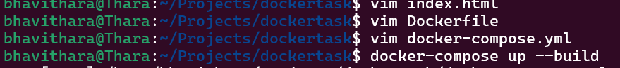

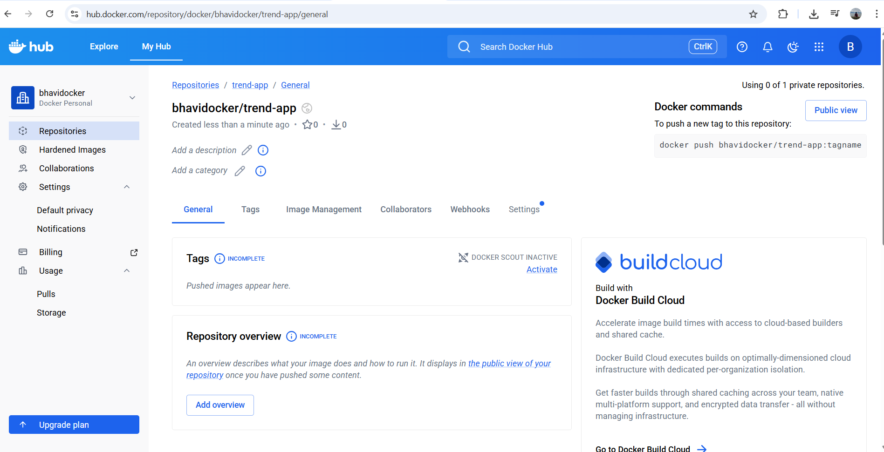

docker build -t trend-app .
docker tag trend-app bhavidocker/trend-app:latest
docker push bhavidocker/trend-app:latest

